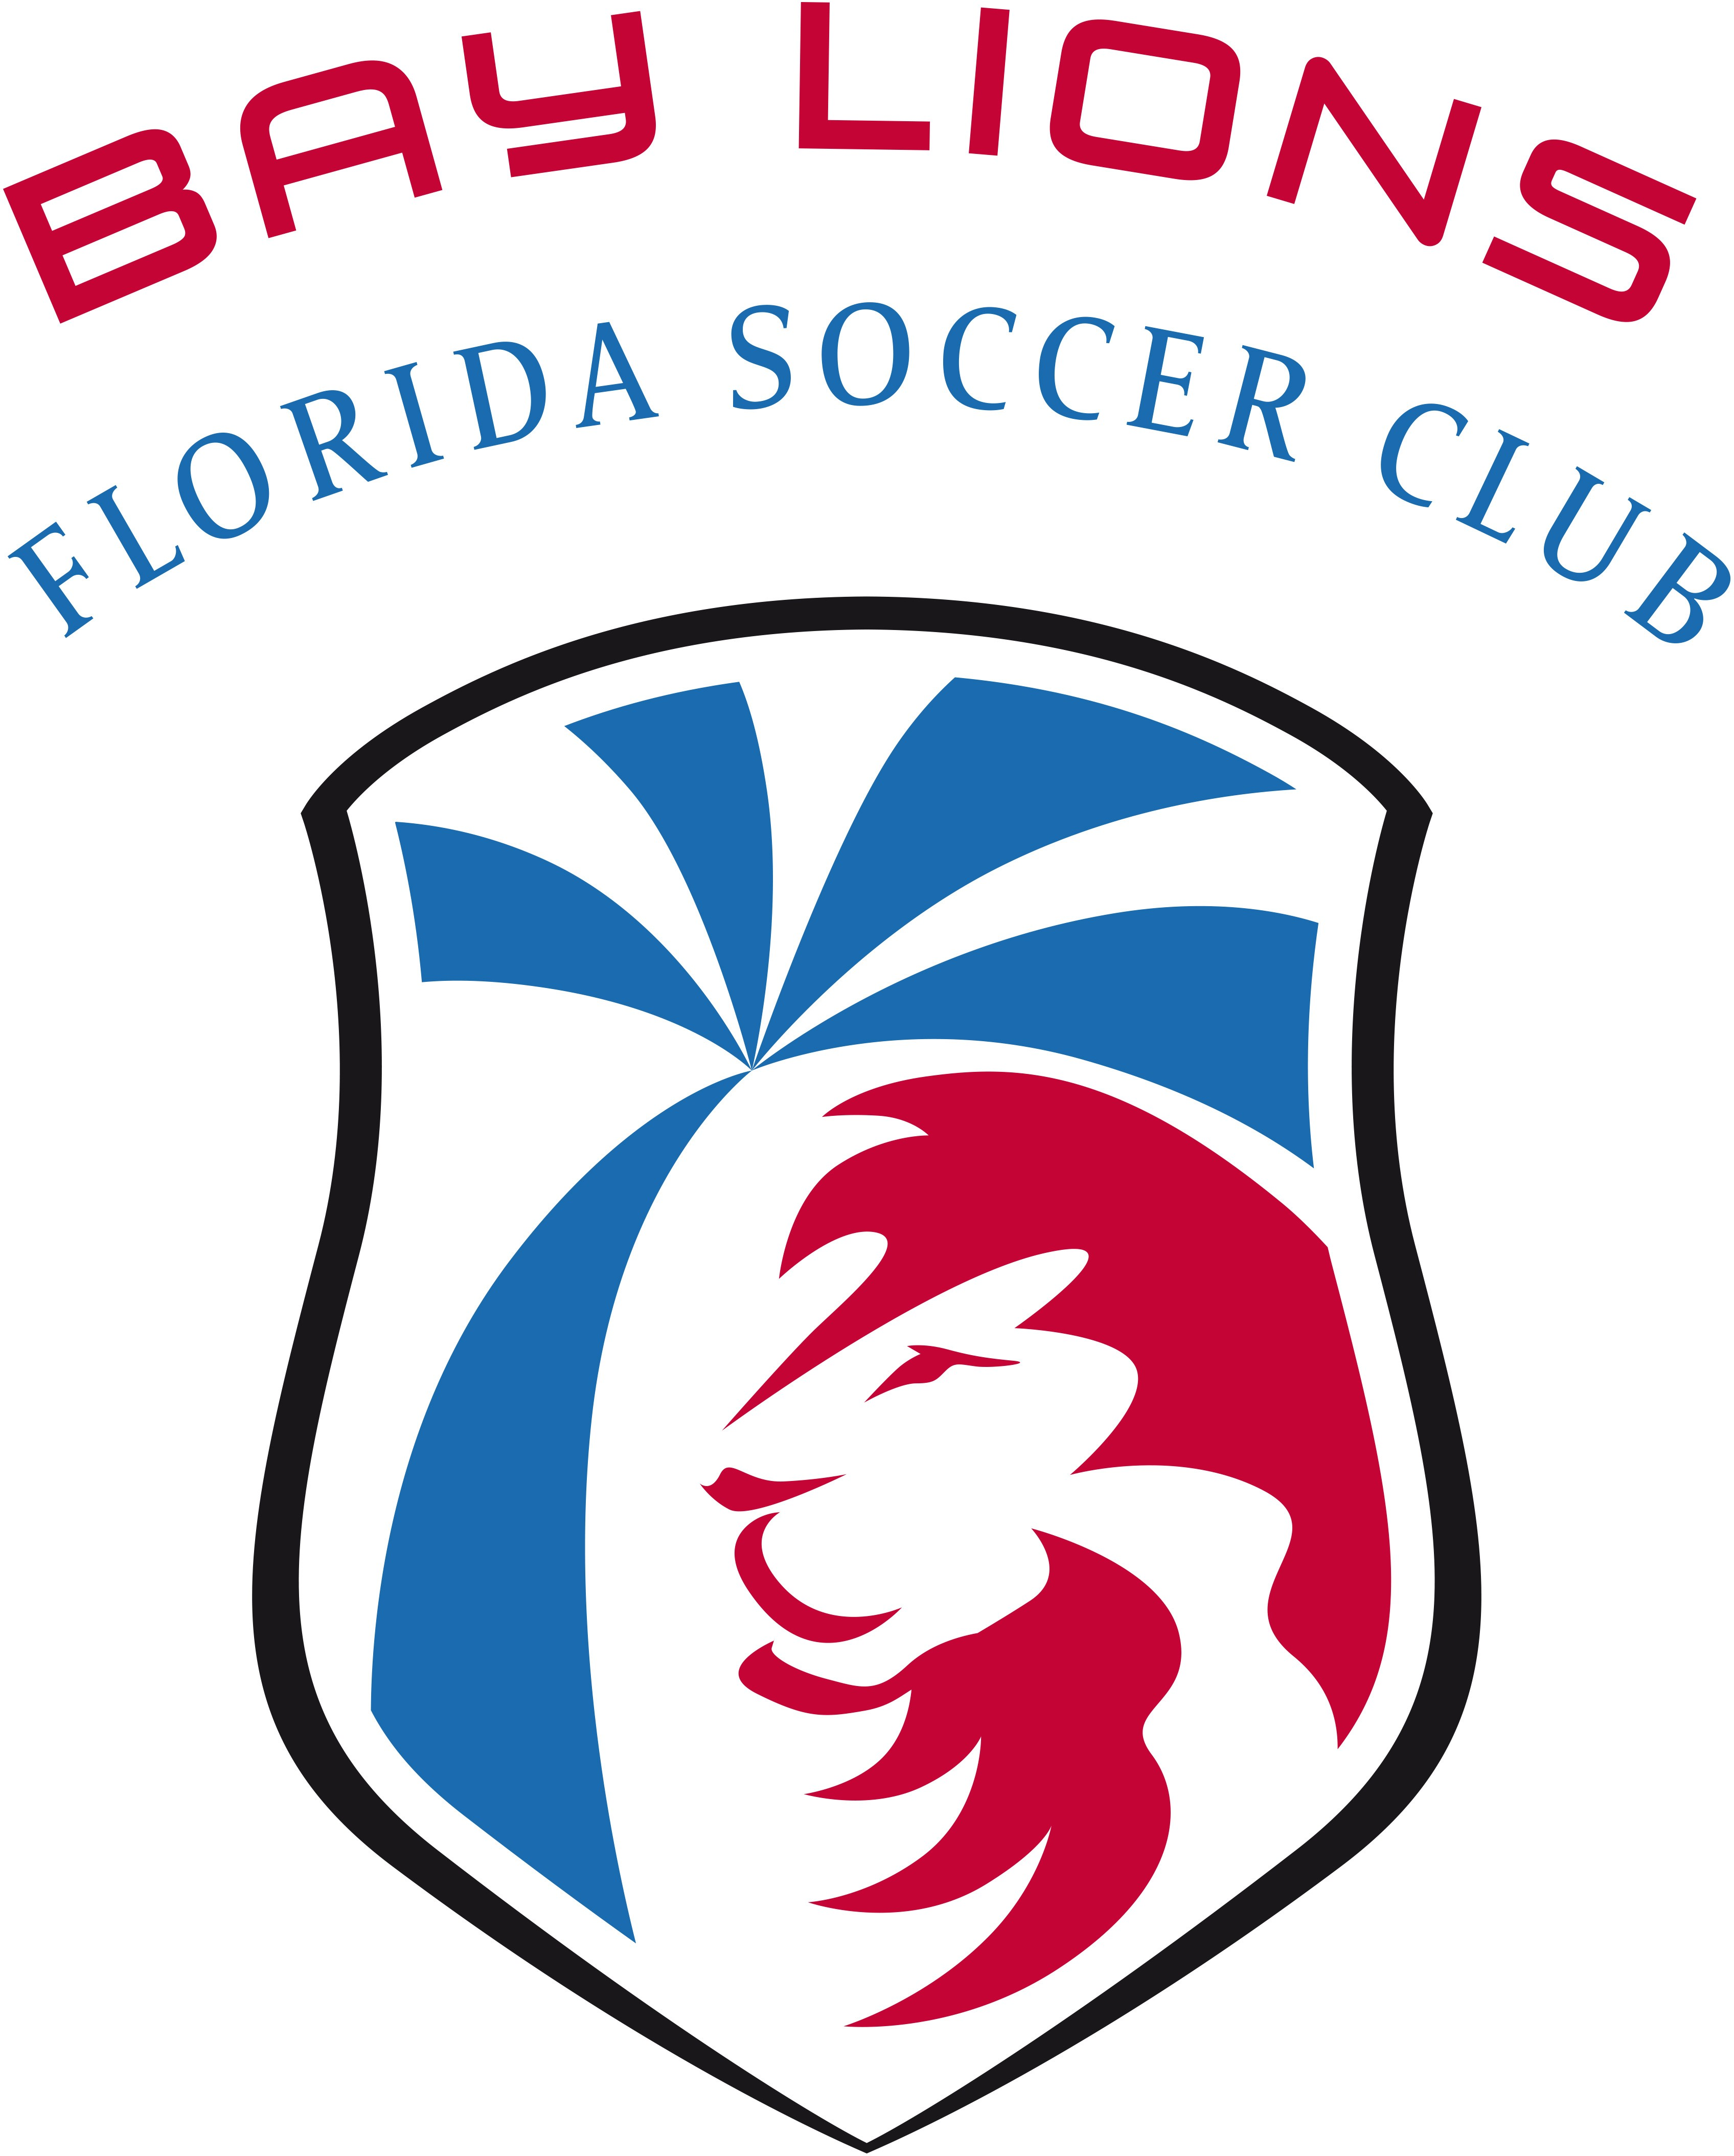
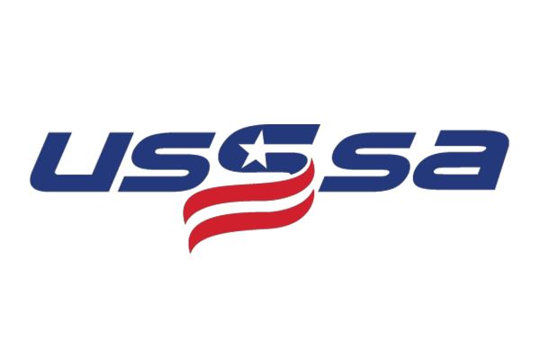

Participant Waiver Form

Player Name:

Age: DOB: / /

Parent / Guardian:
Address:

Home Phone: Cell Phone:

E-Mail Address:

This form must be signed and read before the participant takes part in any try-outs, clinics, testing, training, or competition. By signing this form, the parent or legal guardian of the participant affirms having read it and acknowledges having had sufficient opportunity to have this agreement reviewed by participant’s counsel.

On my own behalf and on the behalf of my heirs, successors and assigns, I hereby forever release and discharge and agree to indemnify and hold harmless Bay Lions Florida Soccer Club and all its related properties, each of their Officers, Directors, Employees, Agents, Shareholders, Members, Partners, Representatives, and all Owners and Operators of all sites at which Bay Lions Florida Soccer Club and any Bay Lions Florida Soccer Club related activity including without limitation clinics, try-outs, games and training sessions.

I understand and acknowledge that dangers of personal injury are inherent in participation in soccer clinics, try- outs, games or training sessions, and I expressly and voluntarily assume all risk of death or personal injury sustained in the clinics, try-outs, games and training sessions, including but not limited to the risks incurred in all these activities and those arising from hidden, latent or obvious defects in any facilities or equipment used. I acknowledge the possibility that my successors or I may not fully know the number or magnitude of all claims, and agree that this release is a full and final release of all claims. This release is being signed in consideration of the opportunity to play for the Bay Lions Florida Soccer Club. It is an agreement made under signature and is governed by Florida’s law.

Parent/Guardians signature Date / /

